# 1.Installation Steps:

## If you want to install VuePress globally:

* Open Git Bash Here
* Type npm install -g vuepress

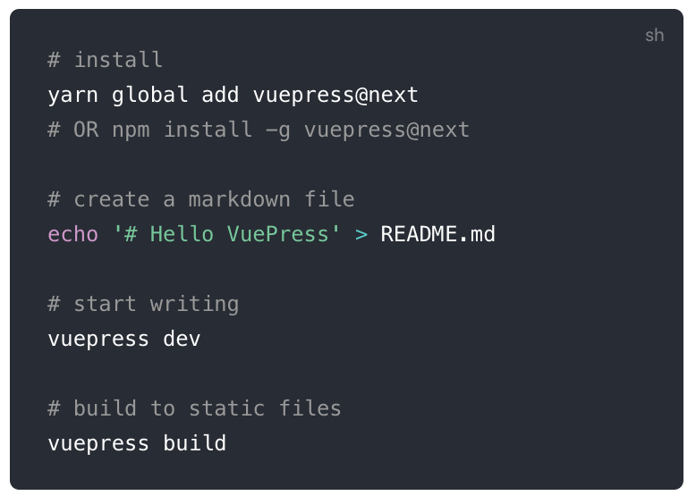

## If you want to install VuePress inside an existing project:

* Open Git Bash Here
* Type npm install -D vuepress

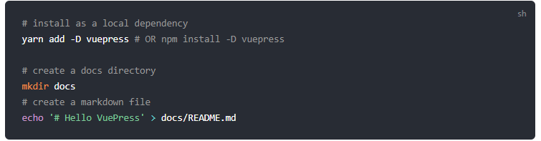

# 2. Starting with VuePress

* Create a README.md file in the project (or repo) you are working. Add #Hello Vuepress to the README.md file.
* Open the folder in Visual Studio Code.
* Create a folder .vuepress inside the project and add config.js file.
* Type the sample code in the config.js file.

module.exports ={

title:'Bearcats',

description:'Northwest Missouri State University'

}

* Now open Git Bash here in the project folder and type vuepress dev. This will start a server at local host. If we open that, we get a page like this

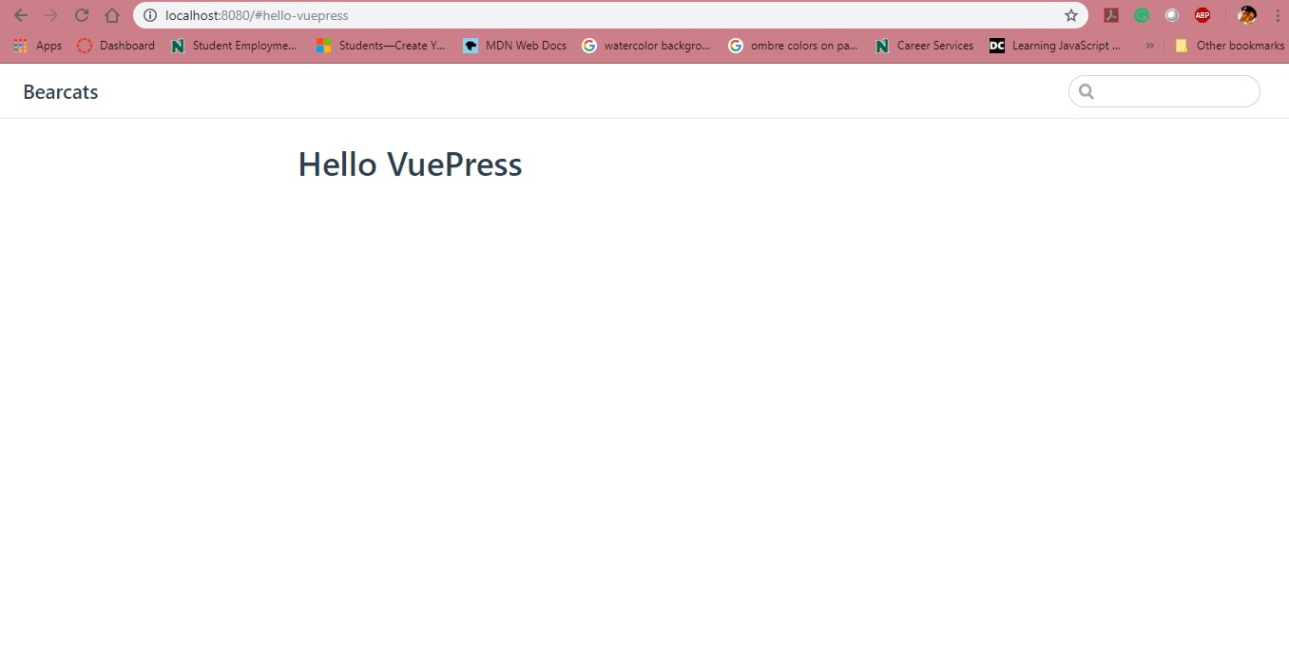

* Now, we add the theme config to get a nicely styled nav bar in your site. Open config.js and add the following code.

module.exports={

title:'Bearcats',

description:'Northwest Missouri State University',

themeConfig: {

nav:[

{text: 'Home', link:'/'},

{text: 'Guide', link:'/'},

{text: 'About me', link:'/'},

]

}

}

* Now, the page looks like this

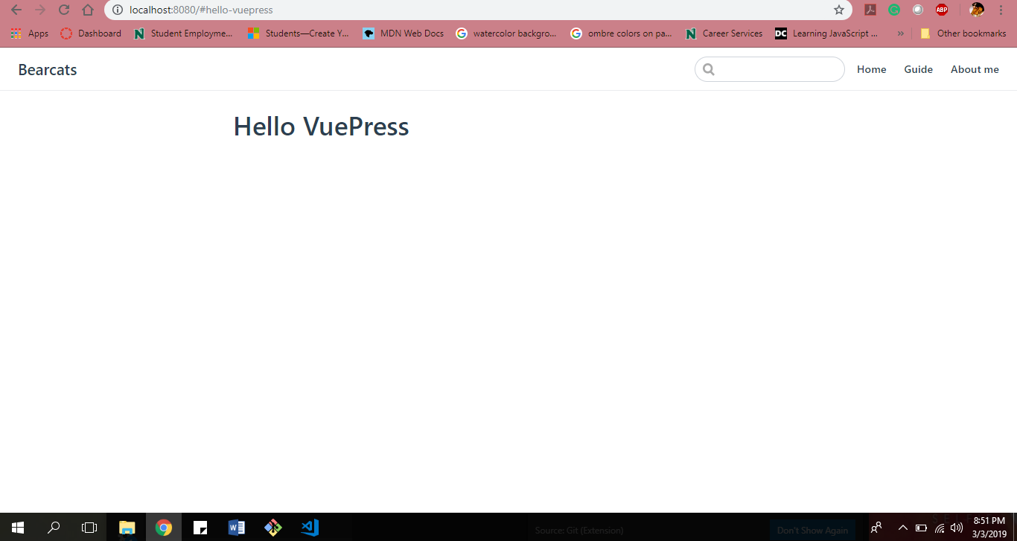

* The default theme provides a homepage layout. To use it, specify home: true plus some other metadata in your root README.md.

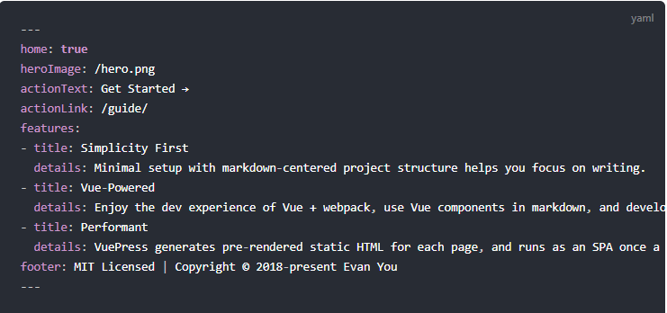

The above mentioned is a sample content.

# 3.References

https://vuepress.vuejs.org/